MAILER

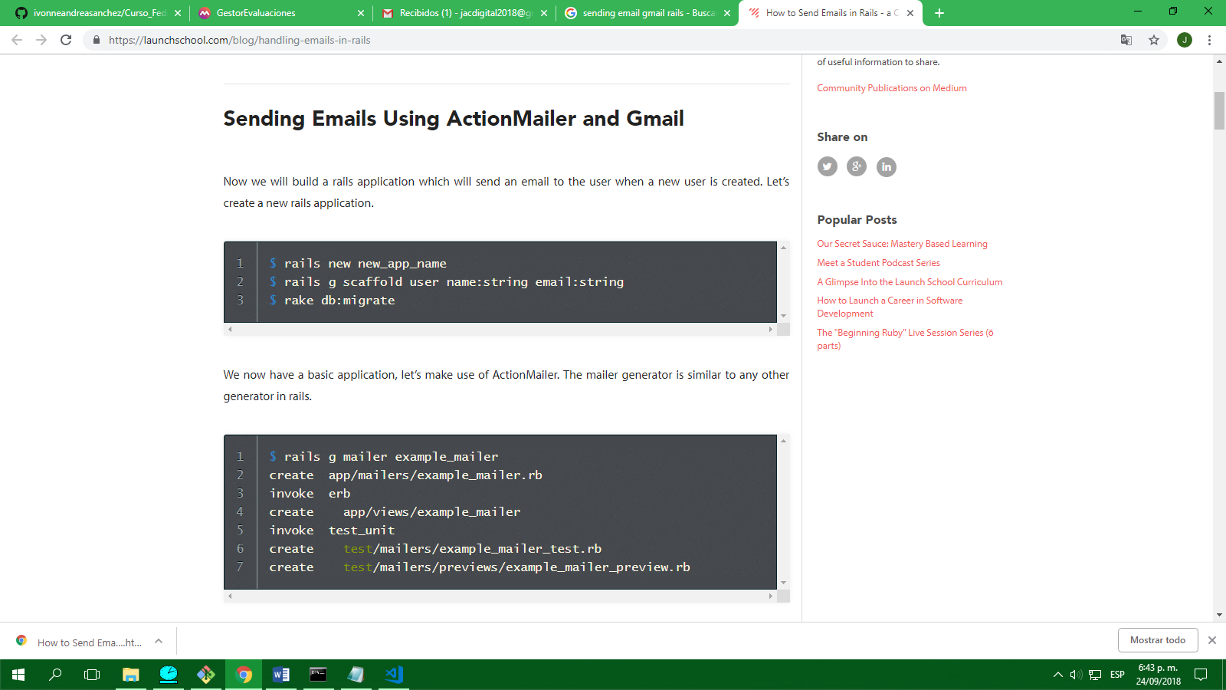

Microsoft Windows [Versión 10.0.15063]

(c) 2017 Microsoft Corporation. Todos los derechos reservados.

C:\WINDOWS\system32>cd..

C:\Windows>cd..

C:\>cd user

El sistema no puede encontrar la ruta especificada.

C:\>cd Users

C:\Users>cd Administrador.000

C:\Users\Administrador.000>cd Downloads

C:\Users\Administrador.000\Downloads>rails new ejemploEmail

create

create README.md

create Rakefile

create .ruby-version

create config.ru

create .gitignore

create Gemfile

run git init from "."

Initialized empty Git repository in C:/Users/Administrador.000/Downloads/ejemploEmail/.git/

create package.json

create app

create app/assets/config/manifest.js

create app/assets/javascripts/application.js

create app/assets/javascripts/cable.js

create app/assets/stylesheets/application.css

create app/channels/application_cable/channel.rb

create app/channels/application_cable/connection.rb

create app/controllers/application_controller.rb

create app/helpers/application_helper.rb

create app/jobs/application_job.rb

create app/mailers/application_mailer.rb

create app/models/application_record.rb

create app/views/layouts/application.html.erb

create app/views/layouts/mailer.html.erb

create app/views/layouts/mailer.text.erb

create app/assets/images/.keep

create app/assets/javascripts/channels

create app/assets/javascripts/channels/.keep

create app/controllers/concerns/.keep

create app/models/concerns/.keep

create bin

create bin/bundle

create bin/rails

create bin/rake

create bin/setup

create bin/update

create bin/yarn

create config

create config/routes.rb

create config/application.rb

create config/environment.rb

create config/cable.yml

create config/puma.rb

create config/storage.yml

create config/environments

create config/environments/development.rb

create config/environments/production.rb

create config/environments/test.rb

create config/initializers

create config/initializers/application_controller_renderer.rb

create config/initializers/assets.rb

create config/initializers/backtrace_silencers.rb

create config/initializers/content_security_policy.rb

create config/initializers/cookies_serializer.rb

create config/initializers/cors.rb

create config/initializers/filter_parameter_logging.rb

create config/initializers/inflections.rb

create config/initializers/mime_types.rb

create config/initializers/new_framework_defaults_5_2.rb

create config/initializers/wrap_parameters.rb

create config/locales

create config/locales/en.yml

create config/master.key

append .gitignore

create config/boot.rb

create config/database.yml

create db

create db/seeds.rb

create lib

create lib/tasks

create lib/tasks/.keep

create lib/assets

create lib/assets/.keep

create log

create log/.keep

create public

create public/404.html

create public/422.html

create public/500.html

create public/apple-touch-icon-precomposed.png

create public/apple-touch-icon.png

create public/favicon.ico

create public/robots.txt

create tmp

create tmp/.keep

create tmp/cache

create tmp/cache/assets

create vendor

create vendor/.keep

create test/fixtures

create test/fixtures/.keep

create test/fixtures/files

create test/fixtures/files/.keep

create test/controllers

create test/controllers/.keep

create test/mailers

create test/mailers/.keep

create test/models

create test/models/.keep

create test/helpers

create test/helpers/.keep

create test/integration

create test/integration/.keep

create test/test_helper.rb

create test/system

create test/system/.keep

create test/application_system_test_case.rb

create storage

create storage/.keep

create tmp/storage

create tmp/storage/.keep

remove config/initializers/cors.rb

remove config/initializers/new_framework_defaults_5_2.rb

run bundle install

The latest bundler is 1.16.4, but you are currently running 1.15.3.

To update, run `gem install bundler`

Fetching gem metadata from https://rubygems.org/...........

Fetching version metadata from https://rubygems.org/...

Fetching dependency metadata from https://rubygems.org/..

Resolving dependencies...

Using rake 12.3.1

Using concurrent-ruby 1.0.5

Using minitest 5.11.3

Using thread_safe 0.3.6

Using builder 3.2.3

Using erubi 1.7.1

Using mini_portile2 2.3.0

Using crass 1.0.4

Using rack 2.0.5

Using nio4r 2.3.1

Using websocket-extensions 0.1.3

Using mini_mime 1.0.1

Using arel 9.0.0

Using mimemagic 0.3.2

Using public_suffix 3.0.3

Using io-like 0.3.0

Using bindex 0.5.0

Using msgpack 1.2.4 (x86-mingw32)

Using bundler 1.15.3

Using byebug 10.0.2

Using ffi 1.9.25 (x86-mingw32)

Using coffee-script-source 1.12.2

Using execjs 2.7.0

Using method_source 0.9.0

Using thor 0.20.0

Using duktape 2.0.1.0

Using multi_json 1.13.1

Using puma 3.12.0

Using rb-fsevent 0.10.3

Using rubyzip 1.2.2

Using tilt 2.0.8

Using sqlite3 1.3.13 (x86-mingw32)

Using turbolinks-source 5.2.0

Using i18n 1.1.0

Using tzinfo 1.2.5

Using nokogiri 1.8.4 (x86-mingw32)

Using rack-test 1.1.0

Using sprockets 3.7.2

Using websocket-driver 0.7.0

Using mail 2.7.0

Using marcel 0.3.3

Using addressable 2.5.2

Using archive-zip 0.11.0

Using bootsnap 1.3.2

Using childprocess 0.9.0

Using rb-inotify 0.9.10

Using coffee-script 2.4.1

Using uglifier 4.1.19

Using turbolinks 5.2.0

Using activesupport 5.2.1

Using tzinfo-data 1.2018.5

Using loofah 2.2.2

Using xpath 3.1.0

Using chromedriver-helper 2.1.0

Using selenium-webdriver 3.14.0

Using sass-listen 4.0.0

Using rails-dom-testing 2.0.3

Using globalid 0.4.1

Using activemodel 5.2.1

Using jbuilder 2.7.0

Using rails-html-sanitizer 1.0.4

Fetching capybara 3.8.1

Installing capybara 3.8.1

Fetching sass 3.6.0

Installing sass 3.6.0

Using activejob 5.2.1

Using activerecord 5.2.1

Using actionview 5.2.1

Using actionpack 5.2.1

Using actioncable 5.2.1

Using actionmailer 5.2.1

Using activestorage 5.2.1

Using railties 5.2.1

Using sprockets-rails 3.2.1

Using coffee-rails 4.2.2

Using web-console 3.7.0

Using rails 5.2.1

Using sass-rails 5.0.7

Bundle complete! 16 Gemfile dependencies, 76 gems now installed.

Use `bundle info [gemname]` to see where a bundled gem is installed.

Post-install message from sass:

Ruby Sass is deprecated and will be unmaintained as of 26 March 2019.

* If you use Sass as a command-line tool, we recommend using Dart Sass, the new

primary implementation: https://sass-lang.com/install

* If you use Sass as a plug-in for a Ruby web framework, we recommend using the

sassc gem: https://github.com/sass/sassc-ruby#readme

* For more details, please refer to the Sass blog:

http://sass.logdown.com/posts/7081811

C:\Users\Administrador.000\Downloads>cd ejemploEmail

C:\Users\Administrador.000\Downloads\ejemploEmail>rails g scaffold user name:string email:string

invoke active_record

create db/migrate/20180924233640_create_users.rb

create app/models/user.rb

invoke test_unit

create test/models/user_test.rb

create test/fixtures/users.yml

invoke resource_route

route resources :users

invoke scaffold_controller

create app/controllers/users_controller.rb

invoke erb

create app/views/users

create app/views/users/index.html.erb

create app/views/users/edit.html.erb

create app/views/users/show.html.erb

create app/views/users/new.html.erb

create app/views/users/_form.html.erb

invoke test_unit

create test/controllers/users_controller_test.rb

create test/system/users_test.rb

invoke helper

create app/helpers/users_helper.rb

invoke test_unit

invoke jbuilder

create app/views/users/index.json.jbuilder

create app/views/users/show.json.jbuilder

create app/views/users/_user.json.jbuilder

invoke assets

invoke coffee

create app/assets/javascripts/users.coffee

invoke scss

create app/assets/stylesheets/users.scss

invoke scss

create app/assets/stylesheets/scaffolds.scss

C:\Users\Administrador.000\Downloads\ejemploEmail>rake db:migrate

== 20180924233640 CreateUsers: migrating ======================================

-- create_table(:users)

-> 0.0017s

== 20180924233640 CreateUsers: migrated (0.0025s) =============================

C:\Users\Administrador.000\Downloads\ejemploEmail>rails generate mailer crear_usuario

C:\Users\Administrador.000\Downloads\ejemploEmail>rails generate mailer crear_usuario

create app/mailers/crear_usuario_mailer.rb

invoke erb

create app/views/crear_usuario_mailer

invoke test_unit

create test/mailers/crear_usuario_mailer_test.rb

create test/mailers/previews/crear_usuario_mailer_preview.rb

C:\Users\Administrador.000\Downloads\ejemploEmail>

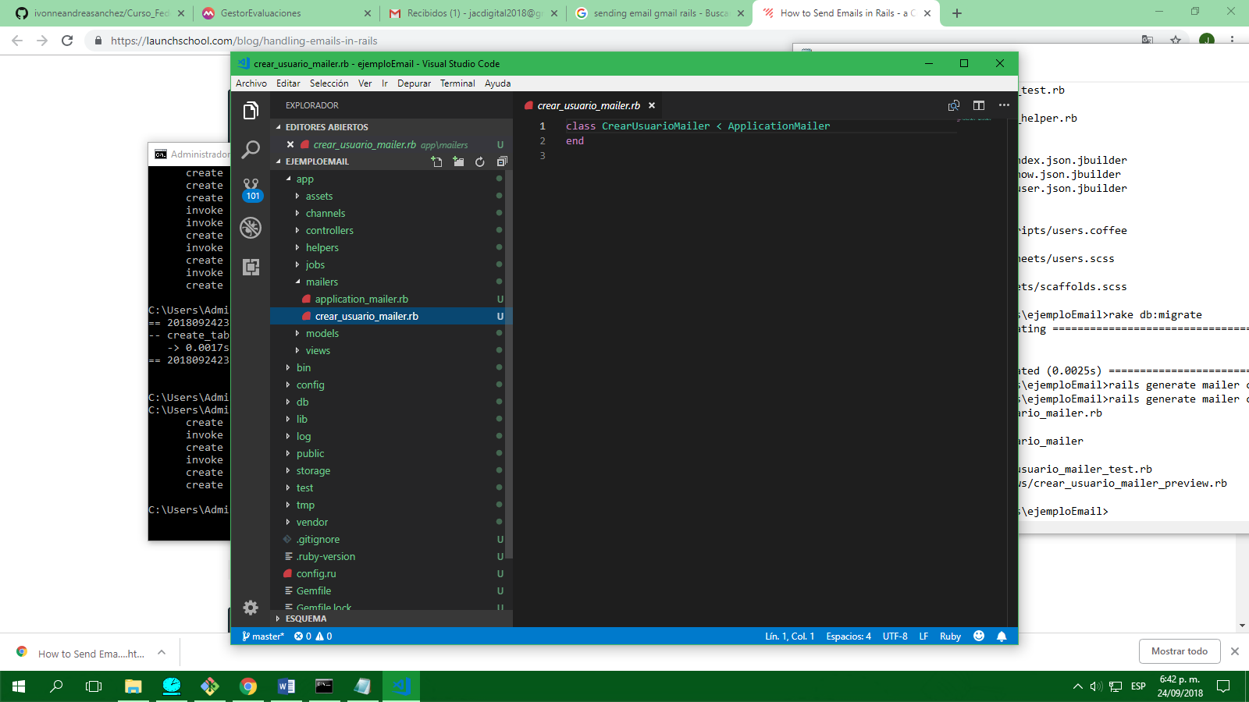

ESTE ARCHIVO ES EL CONTROLADOR PARA EL ENVÍO DE CORREOS

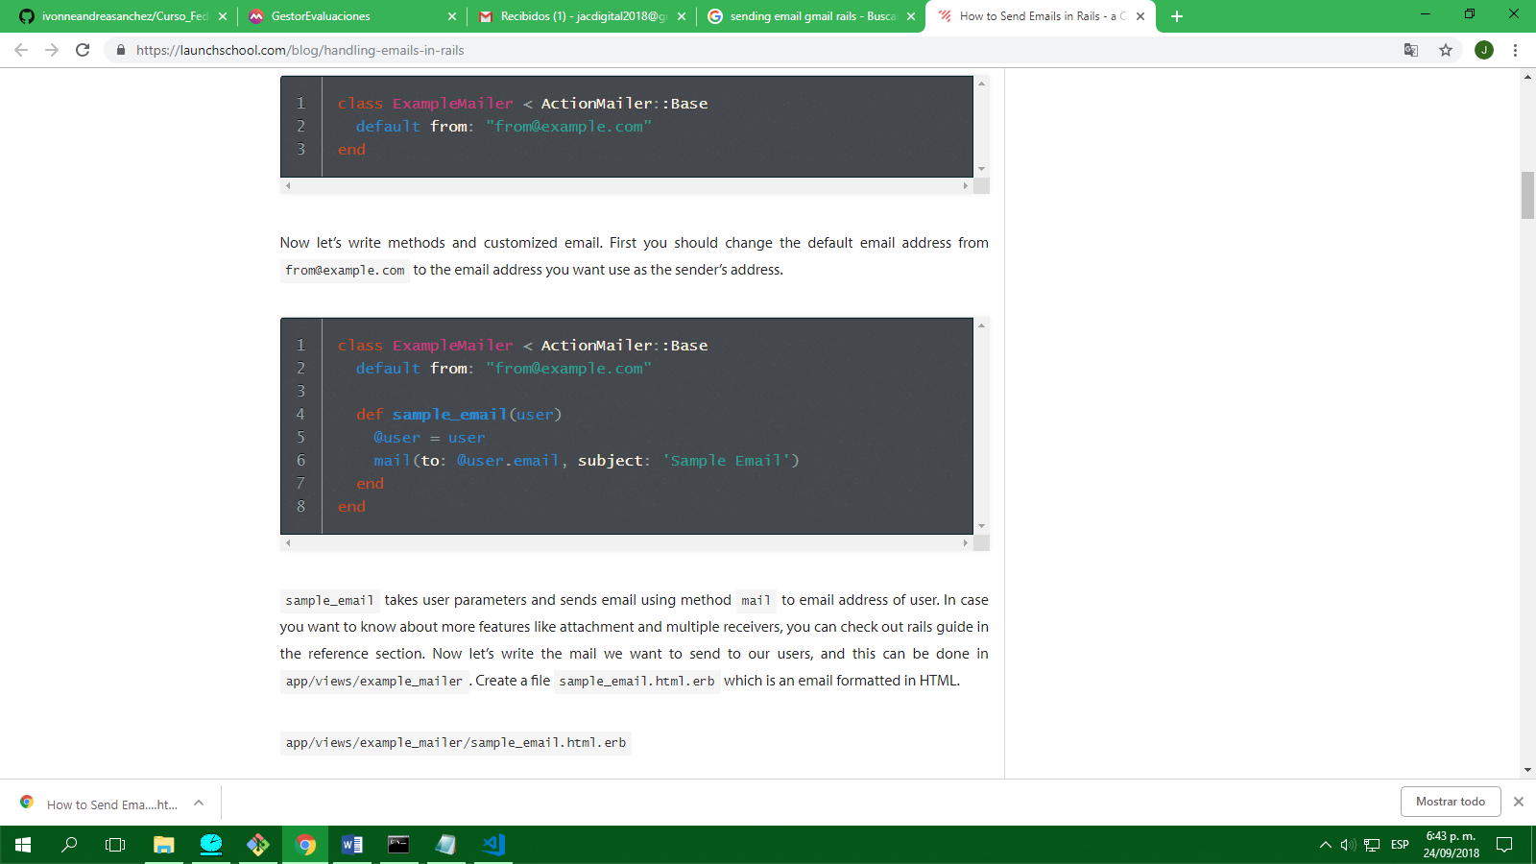

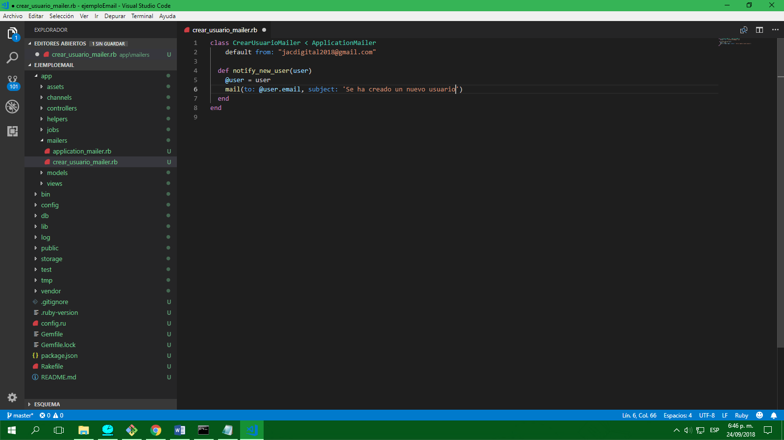

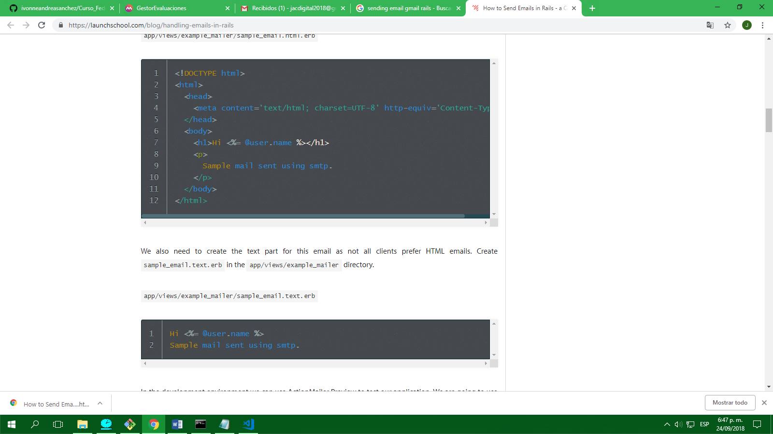

Crear en view una carpeta con el mismo nombre de la función creada anteriormente

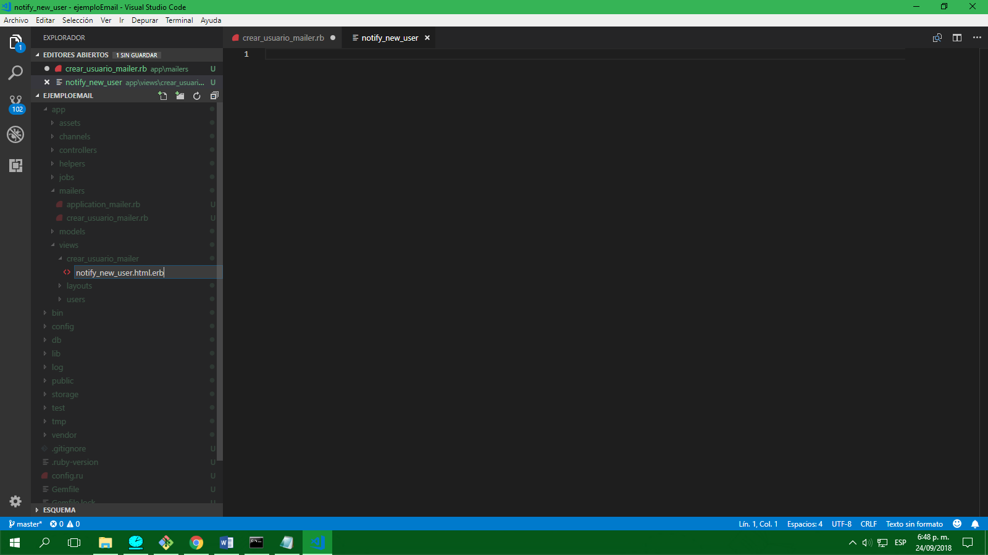

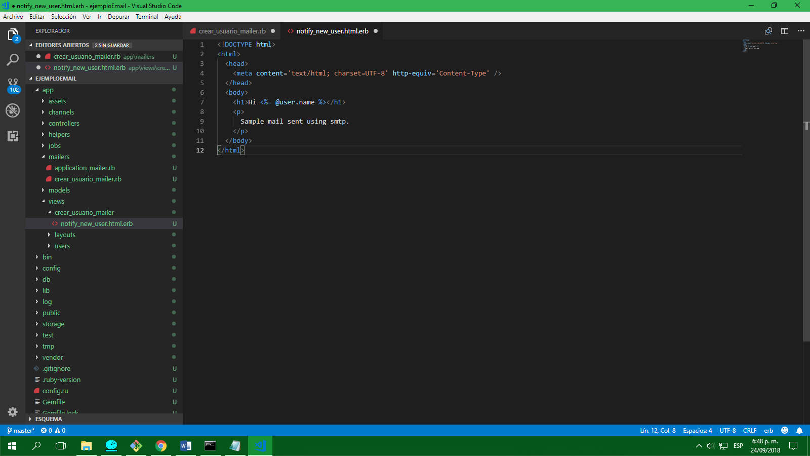

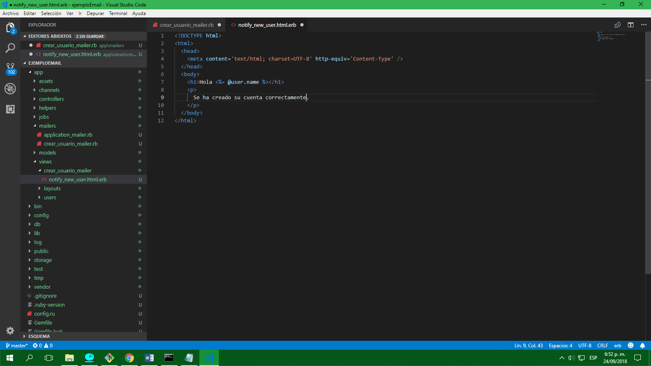

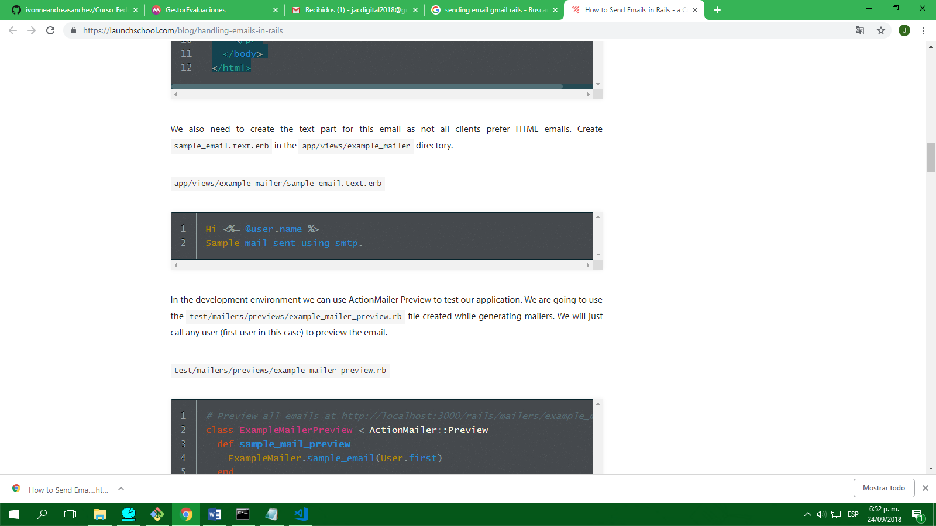

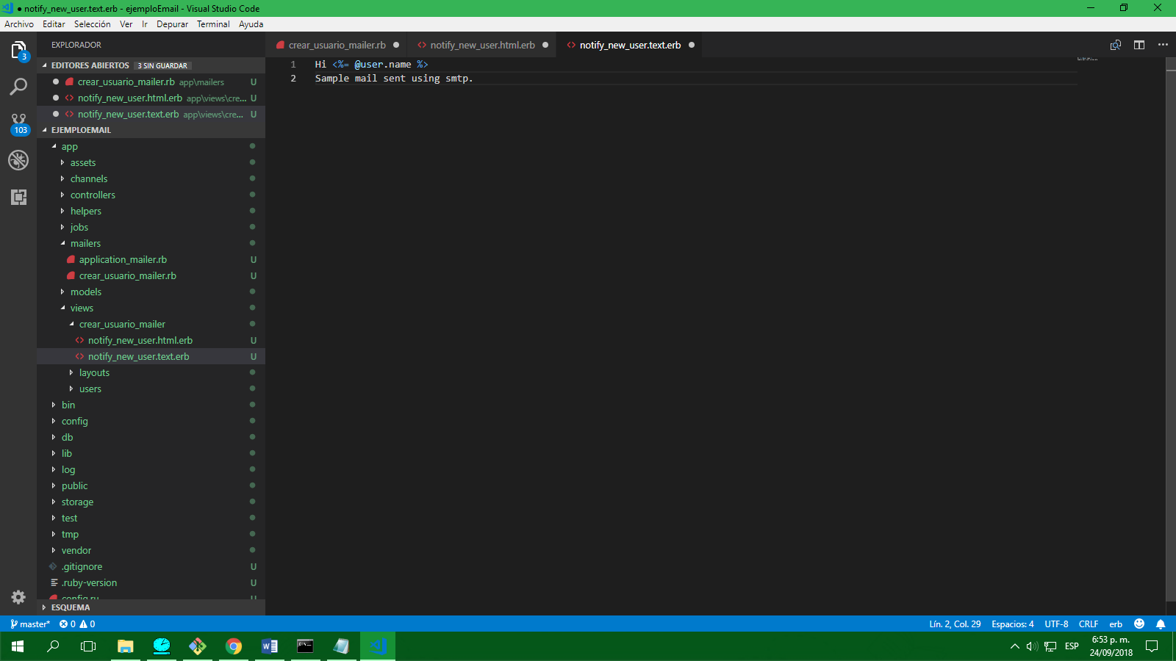

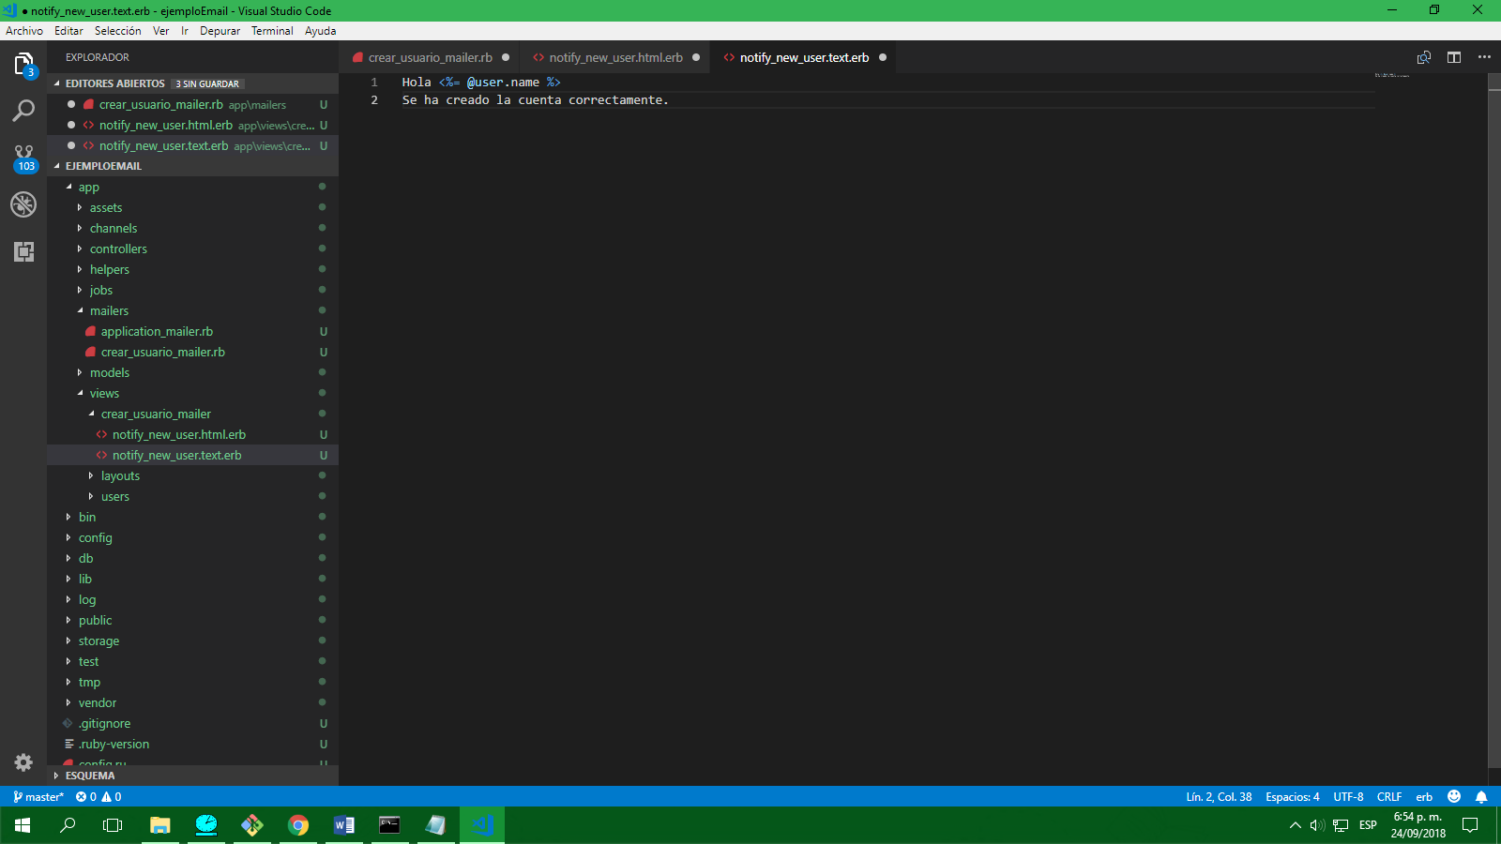

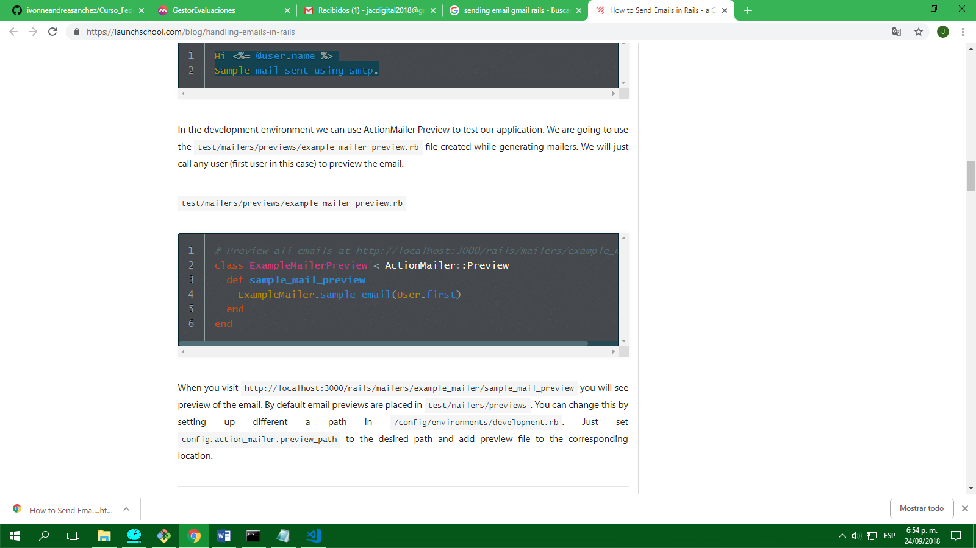

Para que esto funcione se usa la gemma FIGARO

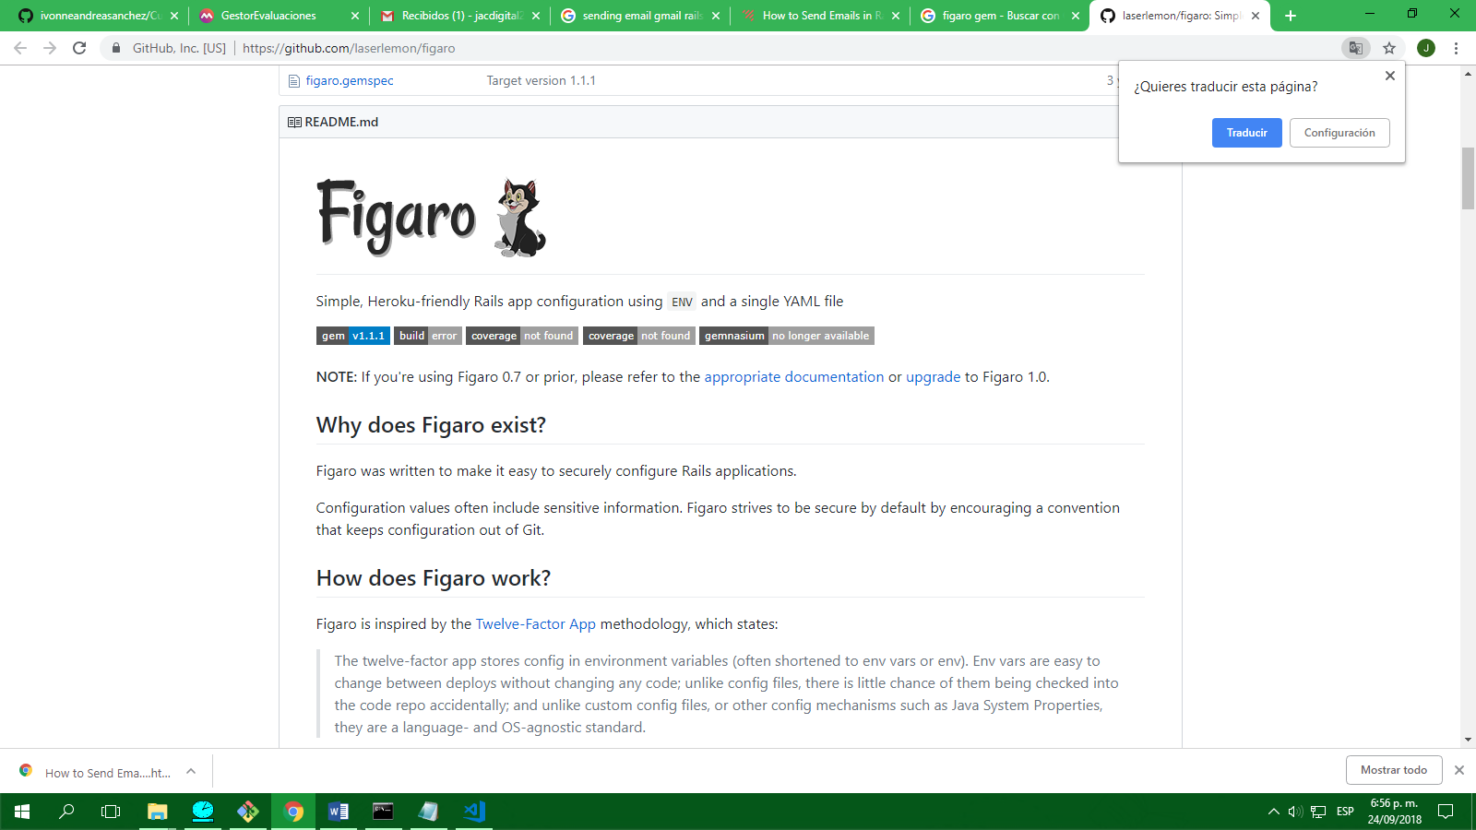

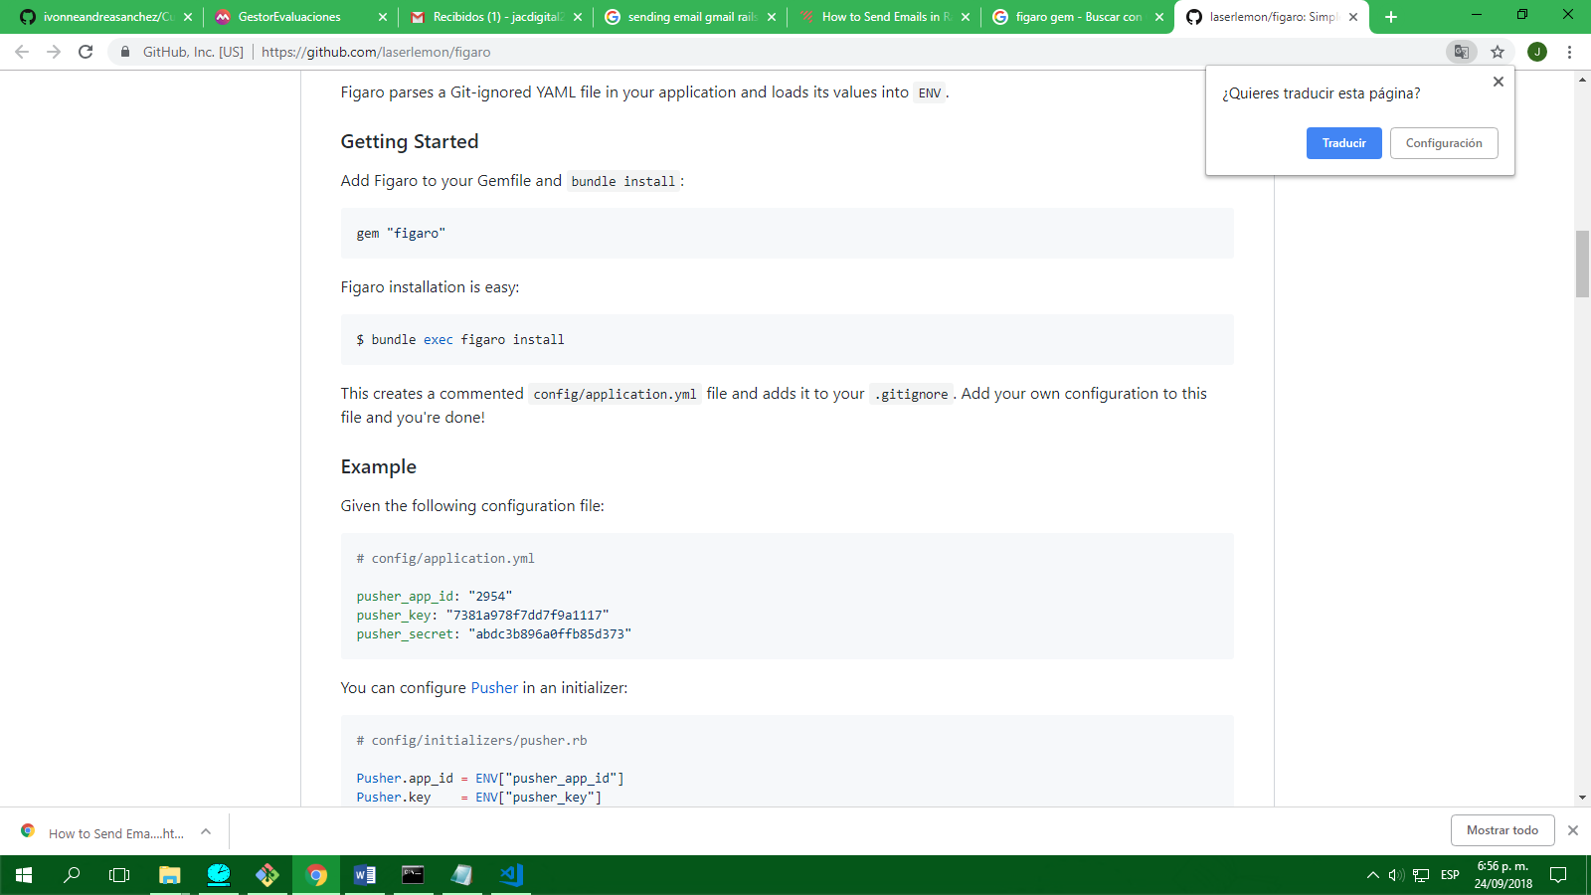

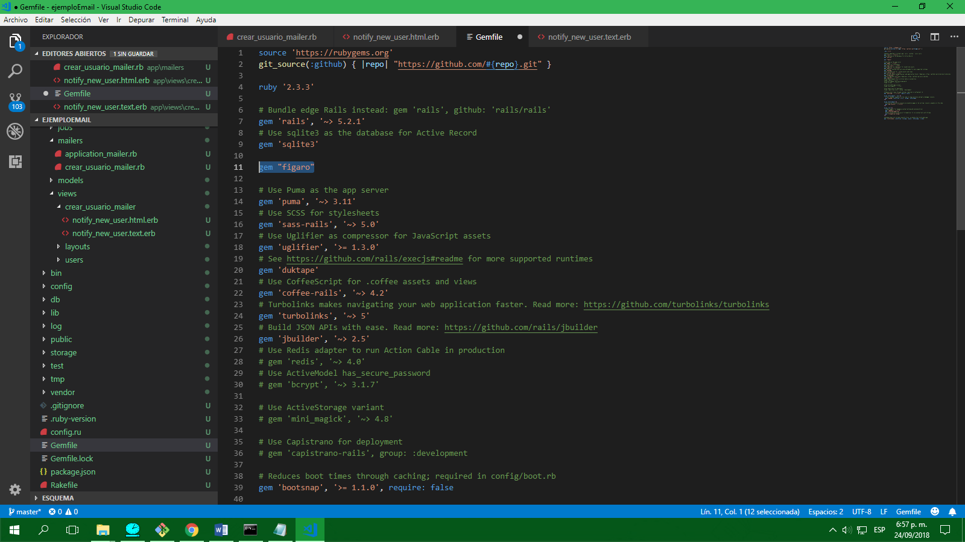

CREAR

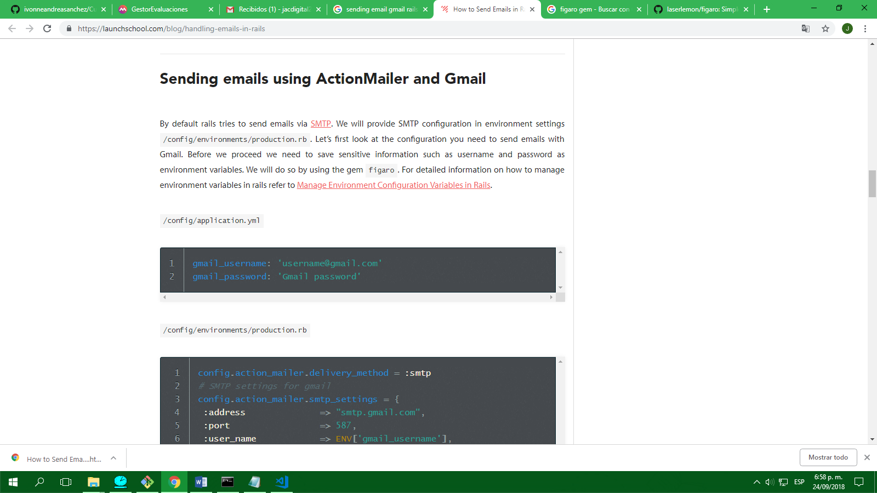

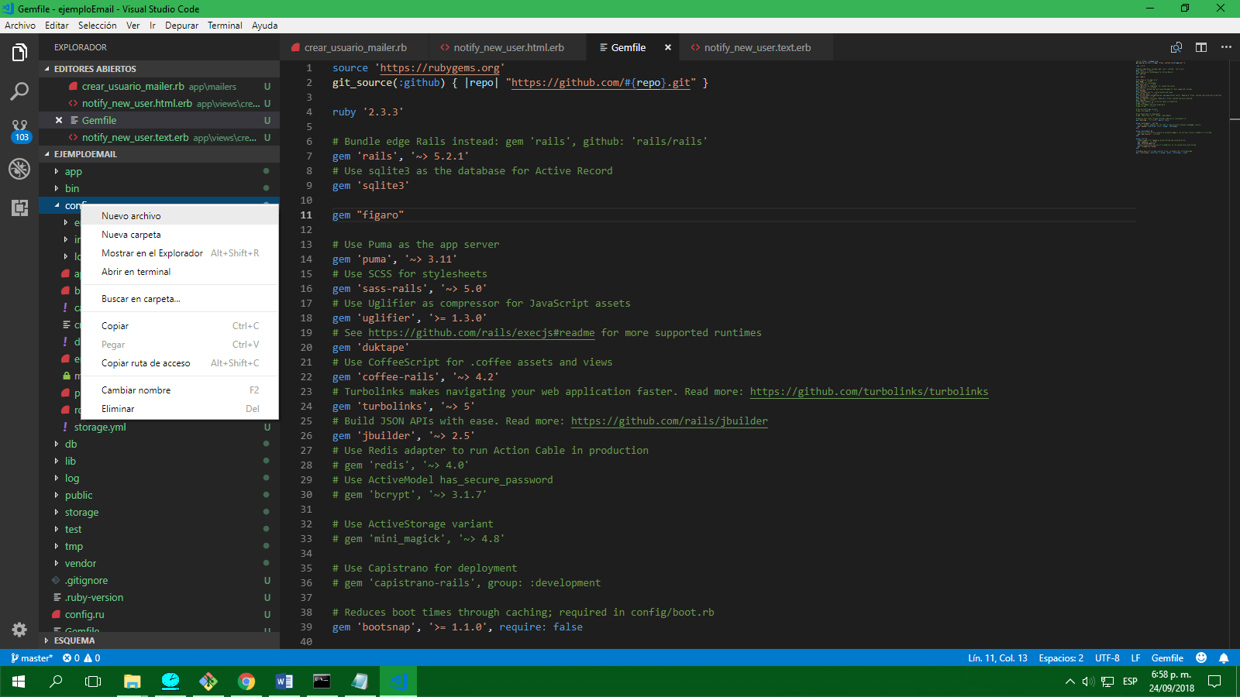

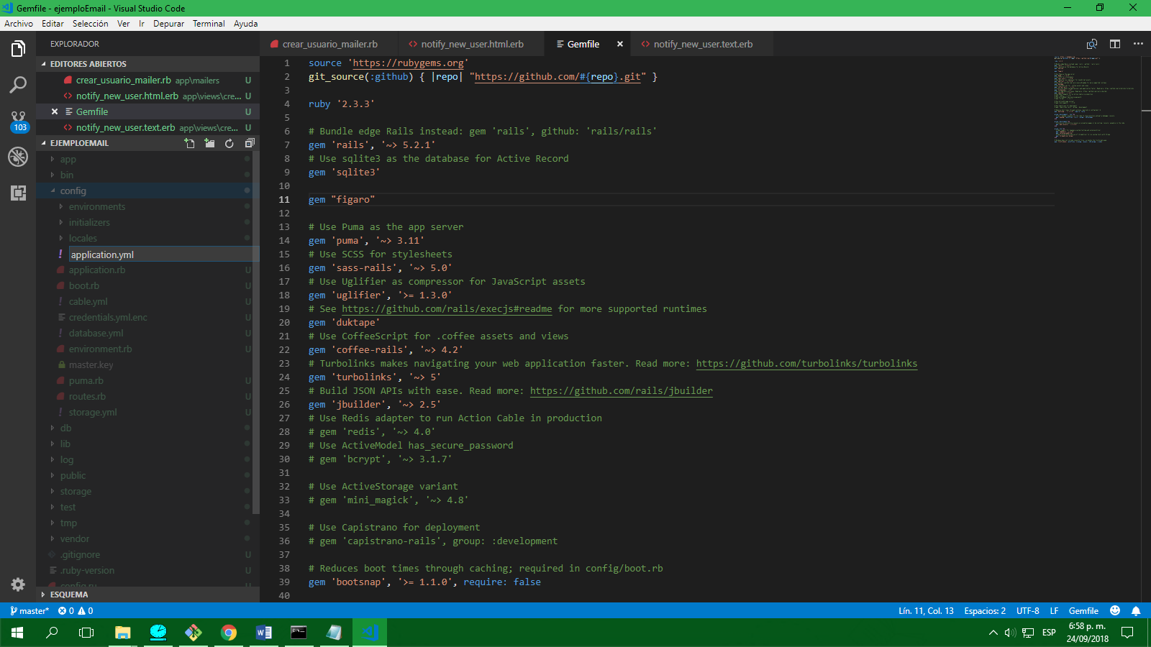

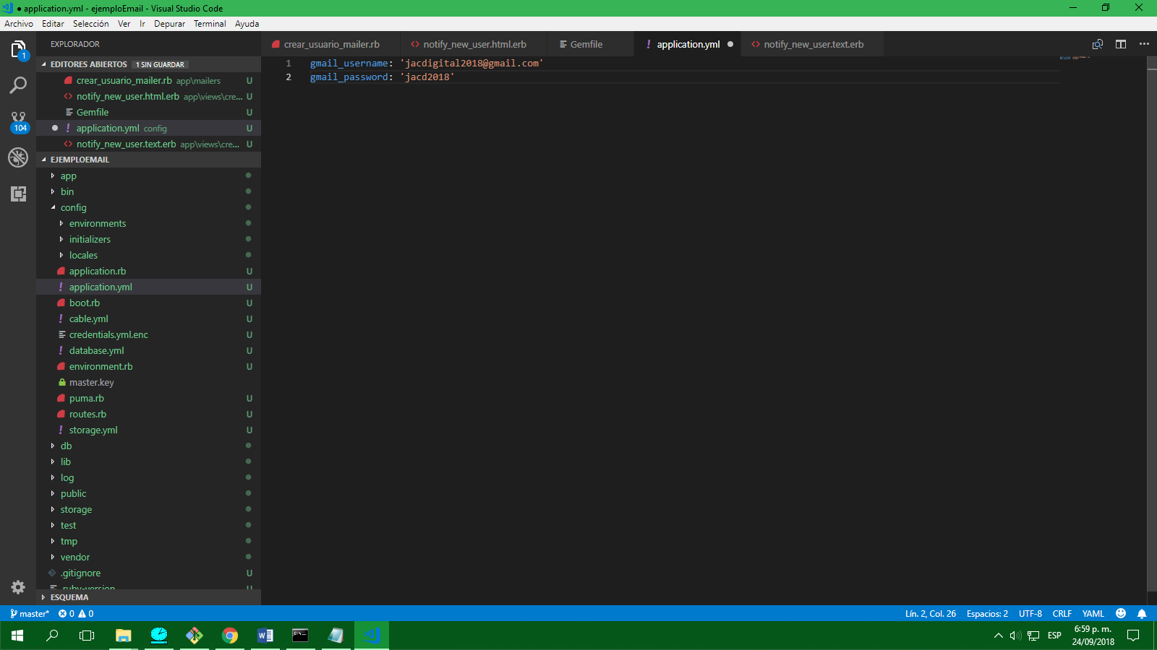

AMBIENTES EN RAILS

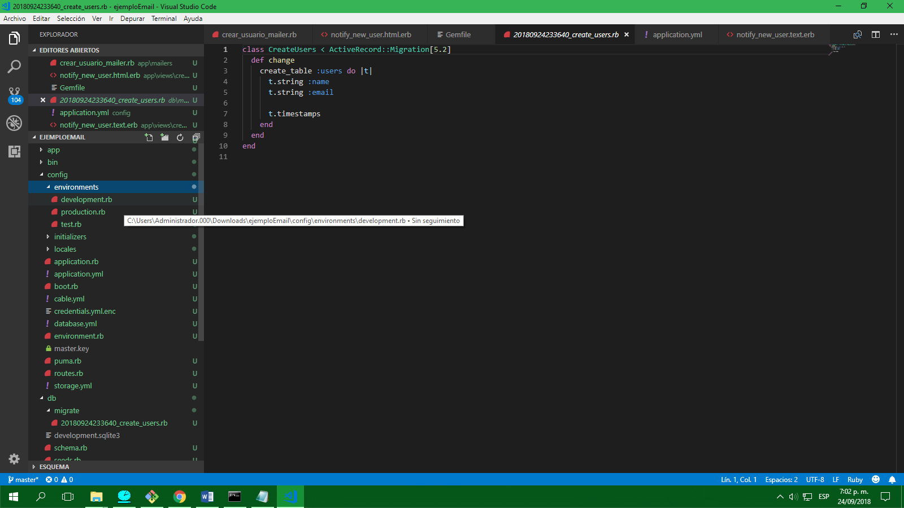

Para correr un ambiente en específico

Ambiente de desarrollo

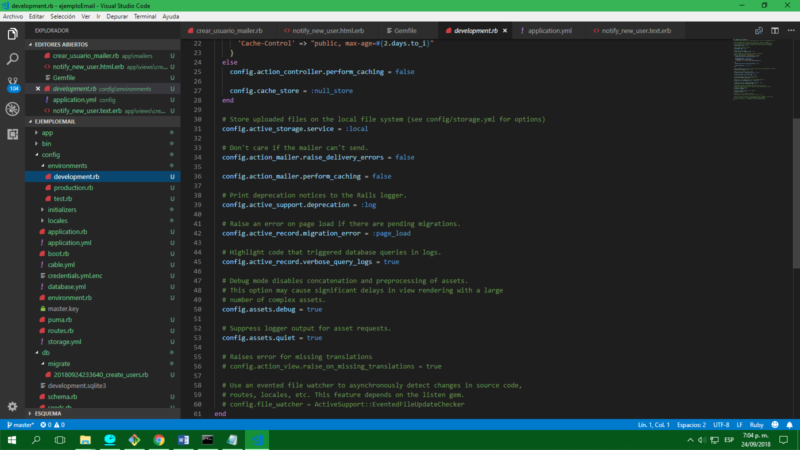

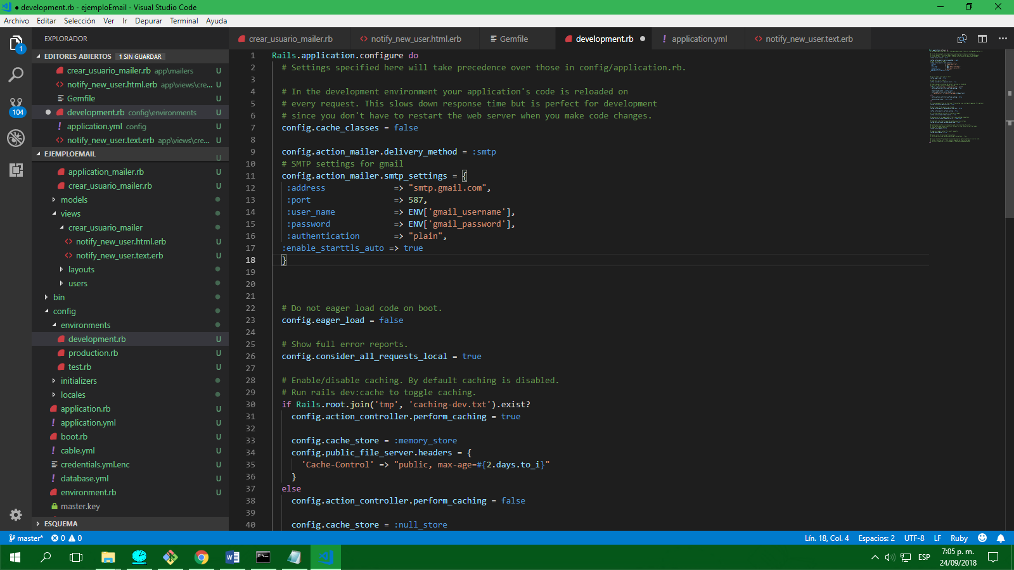

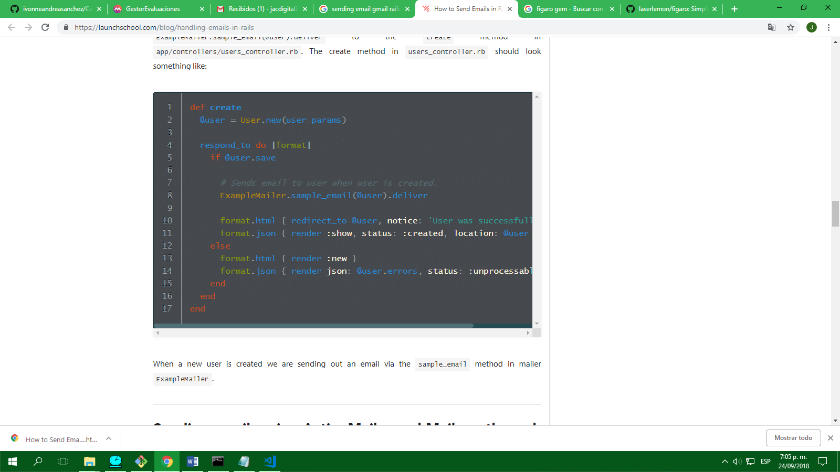

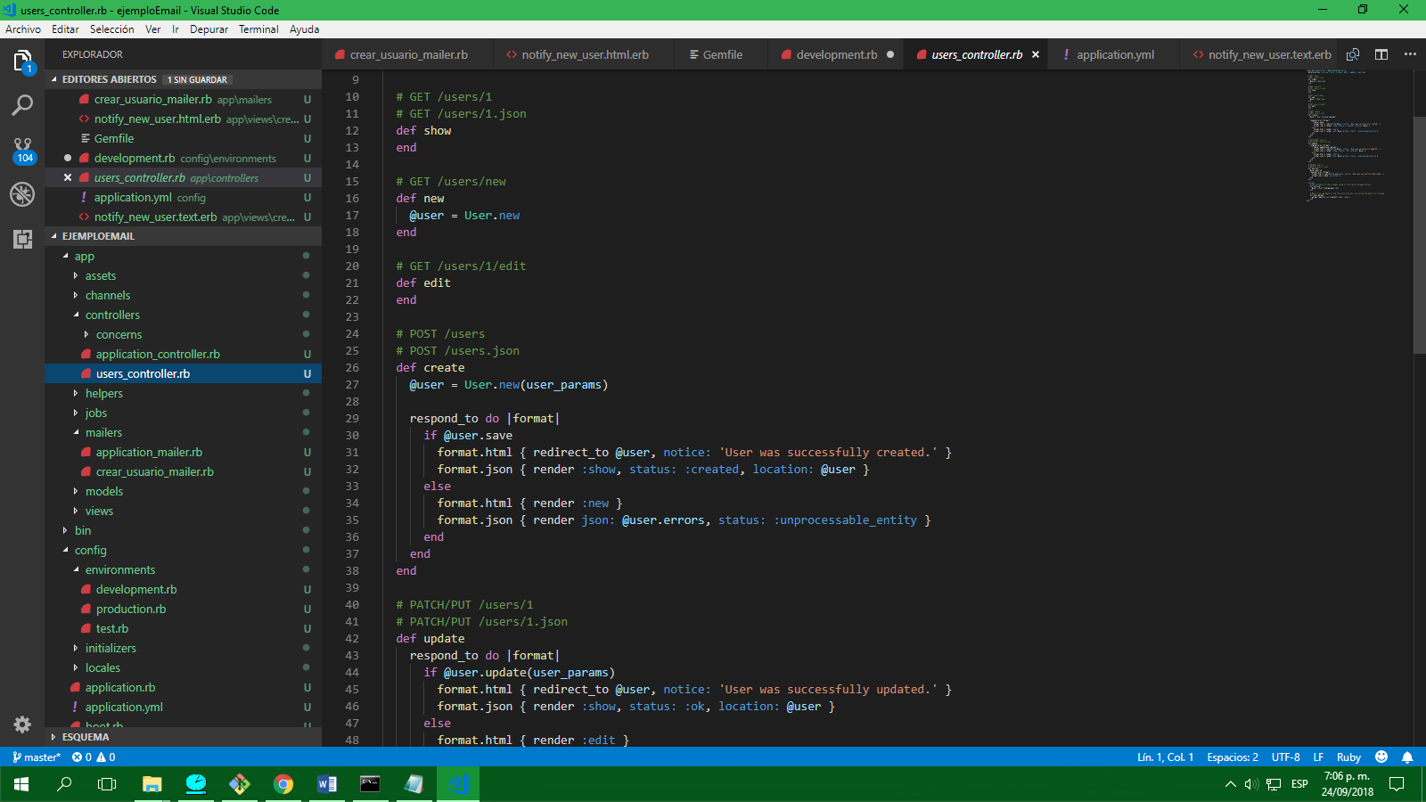

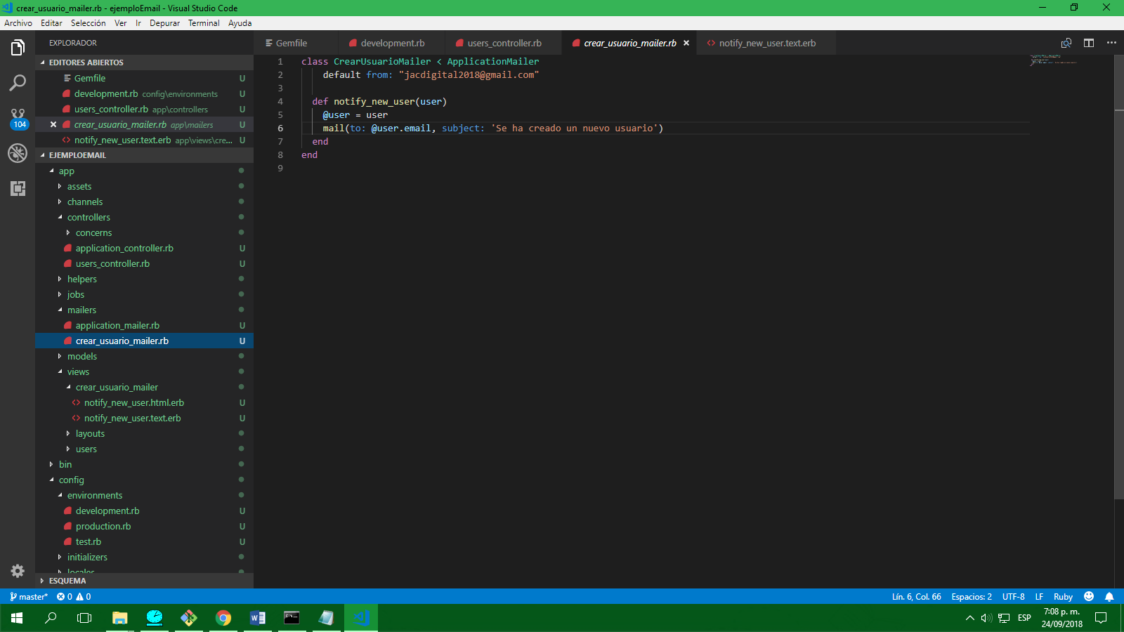

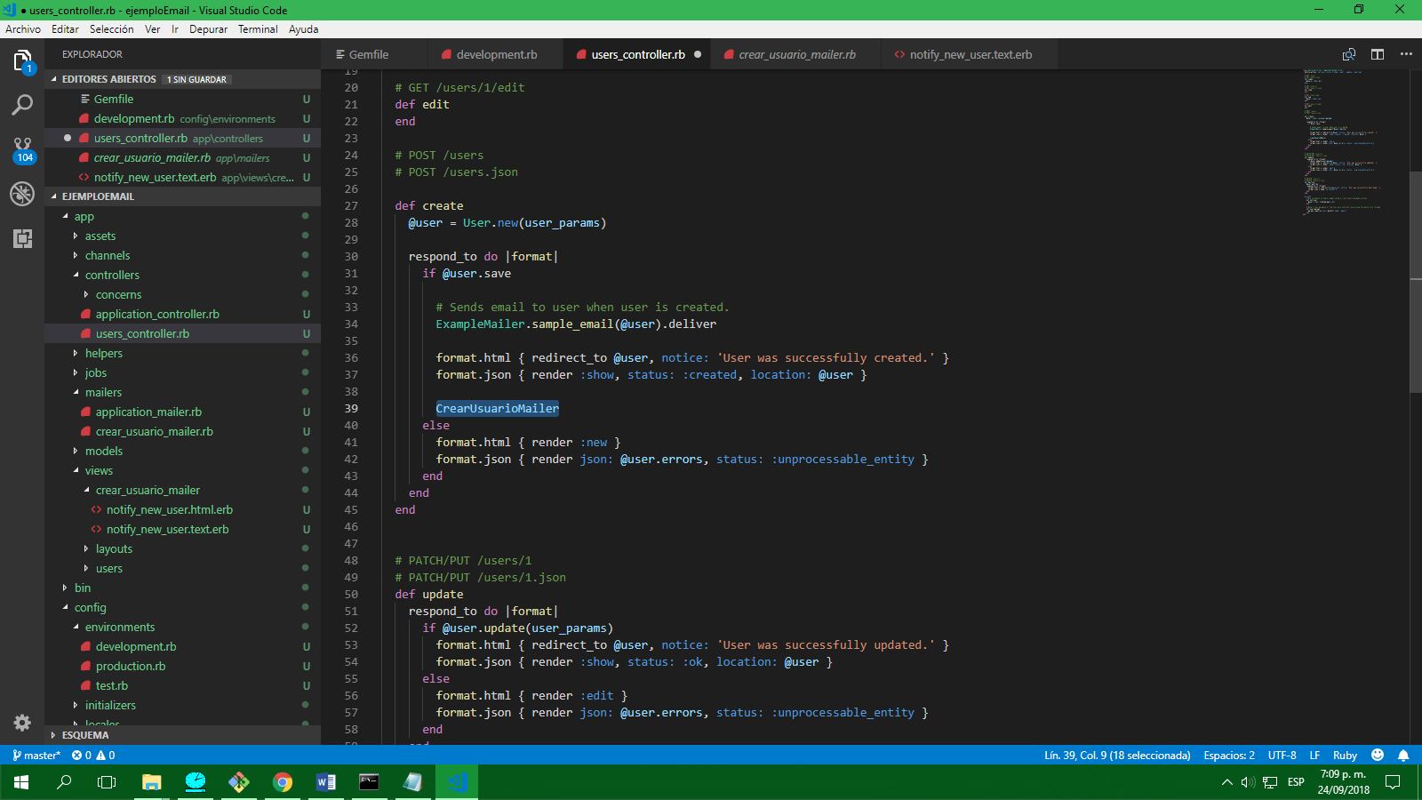

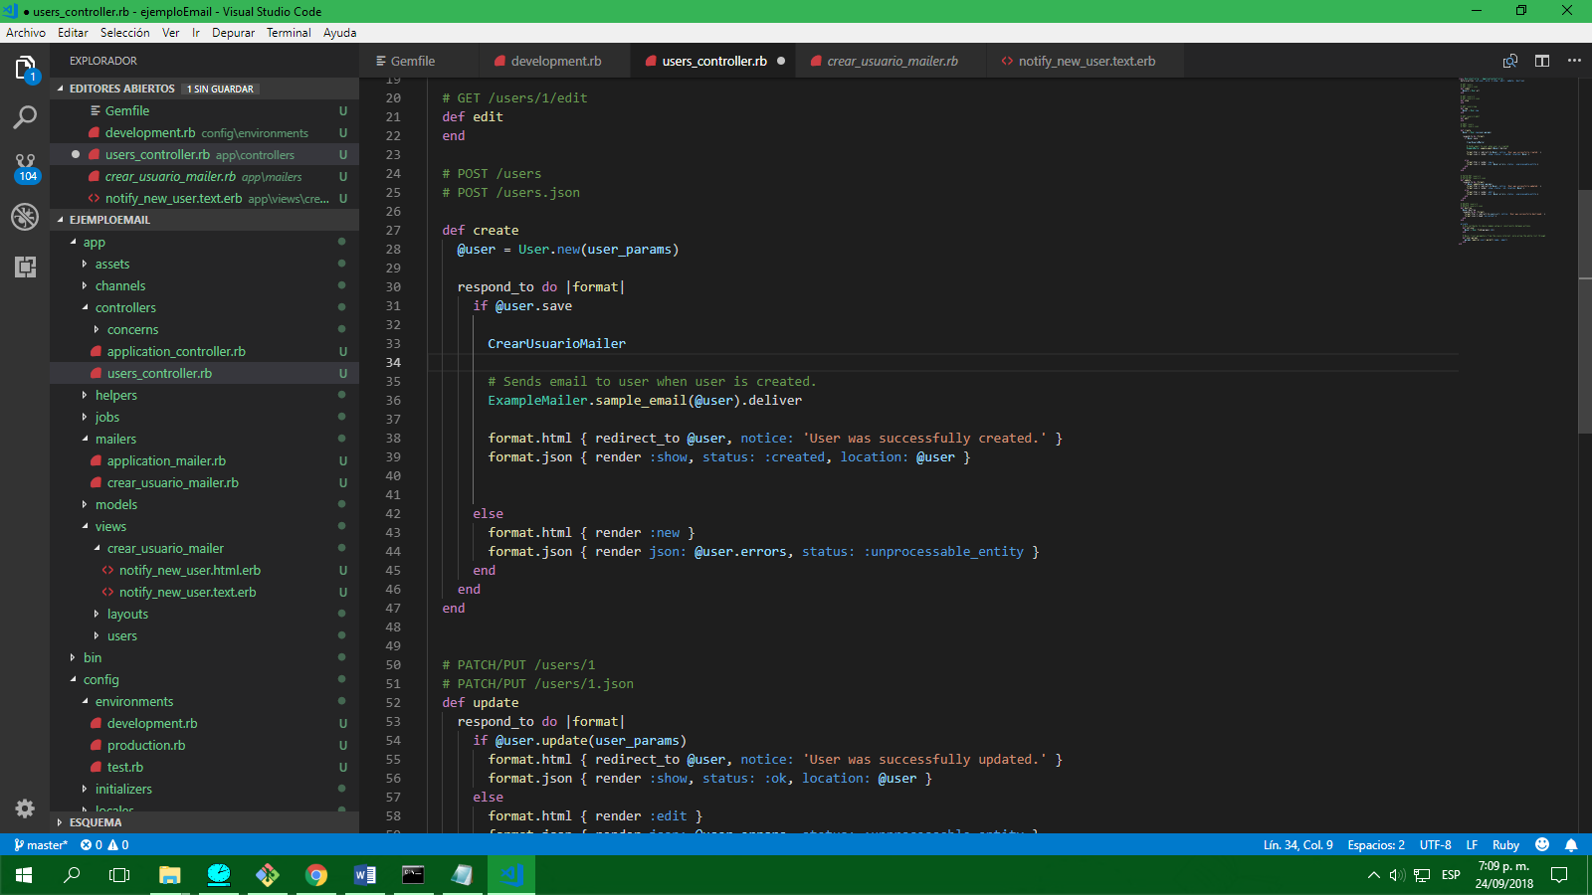

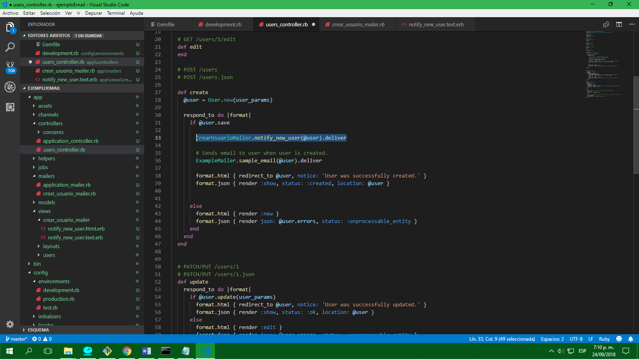

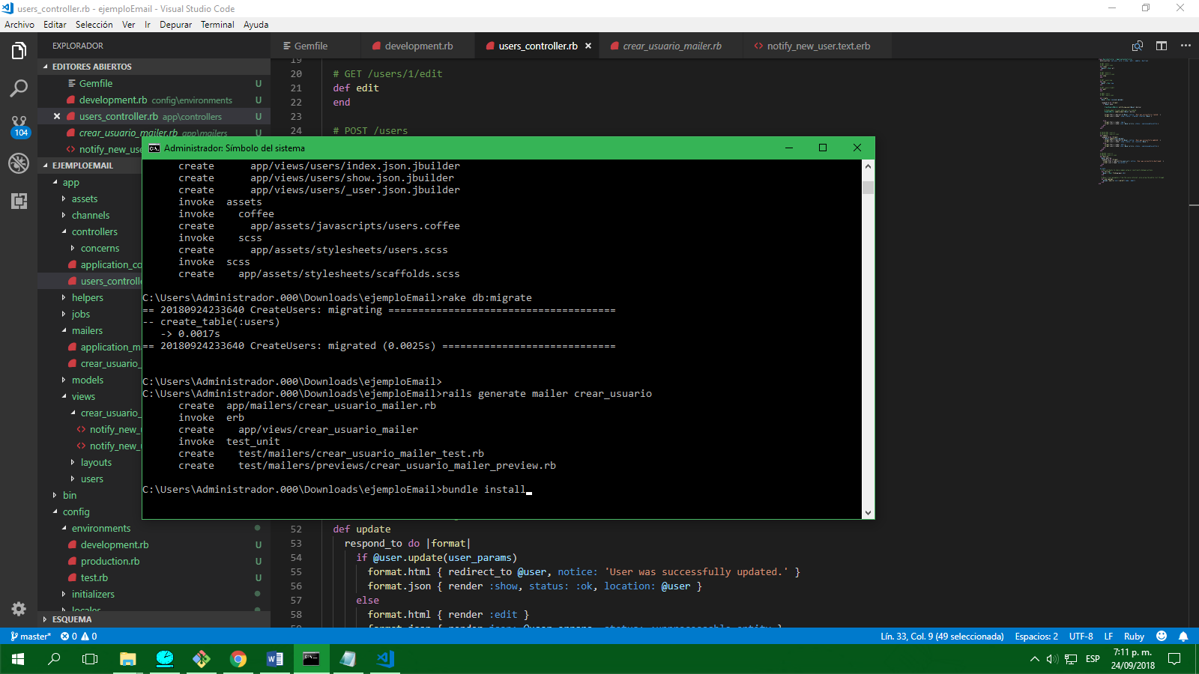

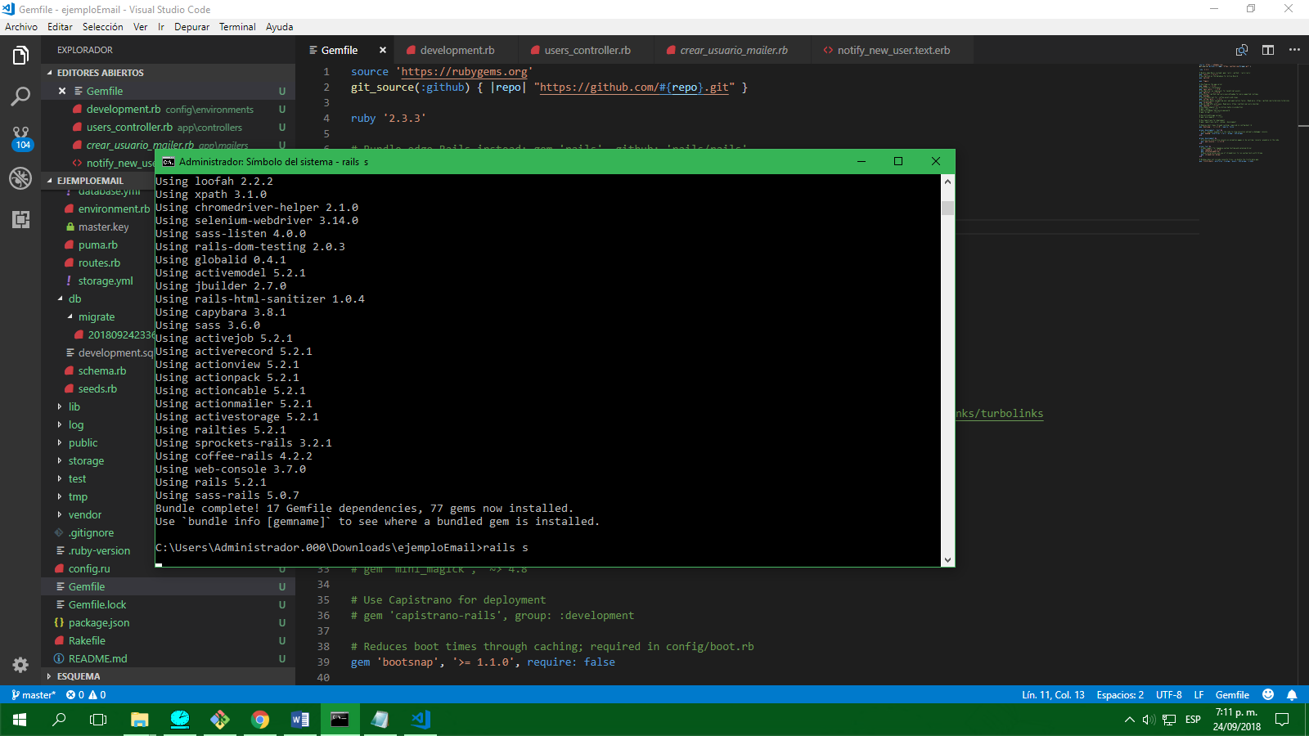

BASH:

Shell Bash, terminal, intérprete que permite ejecutar instrucciones hecha en el pc, ej. Símbolo del sistema y power Shell

Proyecto GNU

Está en todos los equipos que poseen un S.O. sistema operativo, es útil para el manejo de servidores,

Ssh, security Shell Segura, es un protocolo de red, va en el puerto 22, hace un proceso de encriptación.

Ls: listar el contenido de un folder, relativo() o absoluto(dónde estoy)

Mkdir: crear directorio

Cd: ingresar a un directorio

cd.. : volver arriba

cd~ : ir a mi Home

mv: mover de donde se encuentra a donde va

cp copiar con los mismo permisos actuales de un origen a un destino

cp –a copia un archivo igual de un lado a otro copiando los permisos también

por medio de putty

ssh usuario@ip

INSTALAR HEROCU

Plataforma como servicio

Nubes: públicas o privadas

Capas:

Iaas: Infraestructura como servicio

Paas: plataforma como servicio,

Saas: Software como servicio

Herocu, plataforma como servicio,

Instalar,

C:\Users\Administrador.000>heroku login

heroku: Enter your login credentials

Email: ivonneandreas@hotmail.com

Password: **********

Logged in as ivonneandreas@hotmail.com

C:\Users\Administrador.000>

